unentitled

Almost unintentionally we both find ourselves making visual work
about ‘now’ … work with a fond core which touches upon
inconvenient contemporary truths.

Our photo works derive largely from recent ‘in-tent residencies’ on the NSW mid-north coast, and at Little Desert in western Victoria. Whilst simultaneously soothed and bowled over by the magnificence of the natural world on each of these breaks away from the big smoke, our images share a vexatious complexion.

Extreme weather (Firetides, Council Papers), land clearing/food security (Bushland Camping) and concern for ‘country’ in the shameful shadow of the referendum (unentitled) lurk close to the surface.

The striking shadow board in our foyer recalls an earlier era of untrammelled suburban development when limitless ‘growth’ seemed to many of us an unquestioned birthright.

Denise Corrigan & David Watson
April 2024

44 Callan Street | Gadigal Wangal Country | Rozelle
NSW 2039 | 0447 201402|@44_rozelle | @quietworks.online
www.davidwatson.net.au/ | www.quietworks.online/

7 days only!

11am – 5pm Sat 6, Sun 7, Wed 10, Thurs 11, Fri 12, Sat 13, Sun 14 April

The Gadigal Wangal people of the Eora Nation are the traditional Custodians of the Country on which 44 stands. Recognising that sovereignty was never ceded, we pay our deepest respects to Elders past, present and emerging. We acknowledge the creativity, strength and resilience of all First Nations Australians.
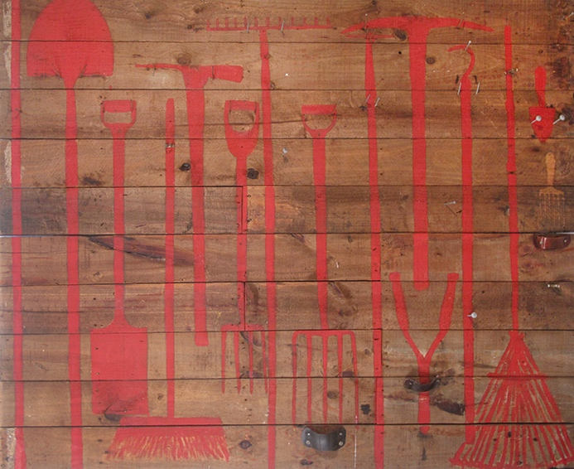

Shadow Board Ken Watson 1970s

6” x 1” Oregon boards, nails, brackets, leather, rubber, paint, 156 x 191 cm

Removed from Dundas garage wall 2009, re-assembled 2017

NFS

My father Ken (1917-2009) was a passionate nature lover and amateur ornithologist who ran a heavy-earth-moving-equipment franchise in Silverwater during the 1960s, selling graders, rollers and scrapers to local councils and cockies across NSW. With post-war suburban ‘progress’ in full swing, for several decades Ken fought a weekend weed-war against privet, lantana and blackberries on (what eventually became) his sloping sheep paddock below our home in Marsden Road, Dundas. In the 1970s Ken re-trained as a real-estate agent and penned remarkably poetic advertisements in the SMH for acreage in the Hills District.

Ken’s shadow board features finely-executed same-size red silhouettes of spades, rakes, clippers and trowels which speak simultaneously of his tending and taming of the land.

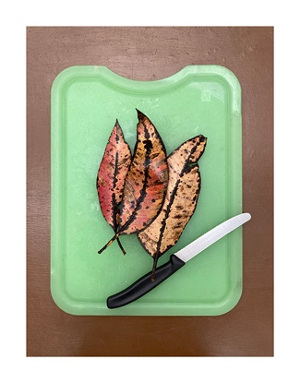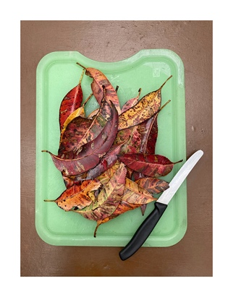

Bushland Camping #1 Denise Corrigan 2023
Bushland Camping #2 Denise Corrigan 2023

Pigment prints on cotton rag art paper, 81 x 63.5 cm

$350 each, Editions of 12

Just before we embarked on our camping holiday up the NSW north-coast I happened to tune in to a radio program about food security to learn that food production is responsible for nearly 90% of deforestation around the world. Settling our tent amongst the gorgeous tallowwoods and their abundant fallen leaves on Worimi Country, I thought further about the program, which also covered new approaches to land restoration, food transportation, and consumer eating habits. The program stayed with me as we later camped quietly by the Barengi Djul (Wimmera River) in western Victoria.

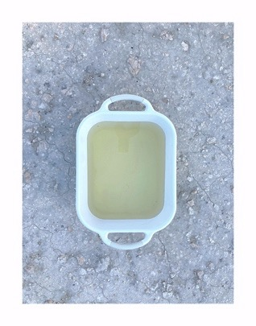

Wutiyeti | camping place by the river, Ackle Bend Denise Corrigan 2023

Pigment print on cotton rag art paper, 81 x 63.5 cm

$350 each, Edition of 12
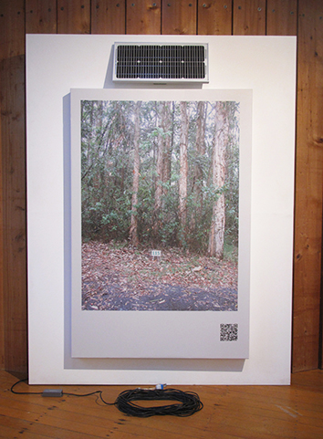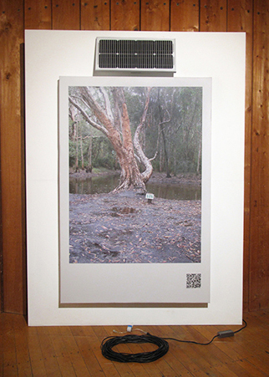

unentitled David Watson 2024

Two 6’ x 4’ wrapped vinyl signs, 20 m power-supply cables + solar panels, 30 x 64 cm

$4500 the pair

In the shameful shadow of the referendum we took refuge with a pair of scruffy-yellow whistling kites and a cast of avian friends on Worimi Country … six nights @ $27/unpowered … rudimentary and restful despite 4” of much-needed rain one evening. Not glamping by any means, but nevertheless, we kept thinking what a hide, how incredible that even so-called progressives like ourselves know so little still about the fragile ecosystems of this distinctive coastal country, about its resurgent First Nations’ culture and languages.
The sociologist Zygmund Bauman once likened the disconnected lives of many in the ‘advanced’ world to those of transient caravan-park dwellers, who pay for a site, plug in to the power, but have little interest in either their fellow residents or the park’s day-to-day operation and bear no responsibility for the site once they’ve departed.
www.davidwatson.net.au/unentitled-2024

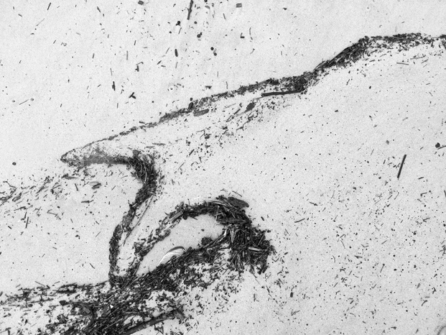

Firetides #3 David Watson 2023

Pure pigment print on cotton rag art paper, 83 x 111 cm, on 12 mm formply

$1100 (mounted), $700 (unmounted), Edition of 8

One late-summer evening in early 2020 we each caught a small bream in the wild surf off back beach, on Gumbaynggirr Country. As the sun sunk slowly behind a milky sky, spots of rain (and squadrons of mosquitoes) failed to dampen pleasant imaginings of the sweet meal we’d soon be enjoying back at camp. But savage pre-Xmas fires in the distant ranges and blackened flood debris vomited from the mouth of the Macleay had taken its toll, and the fish tasted as irritable as the ocean.

Between showers on the beach next morning a receding tide threw up contorted landscapes of bushfire detritus – ashen geologies and spirit forms ceaselessly redrawn by the slop and boil of the sea – as if the universe itself were re-imagining, reconstituting the scarred terrains and communities of our careless anthropocene.

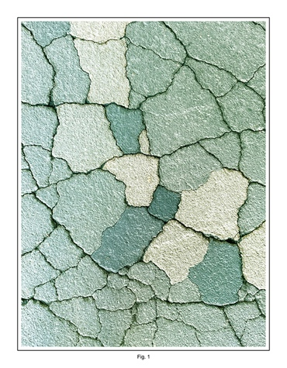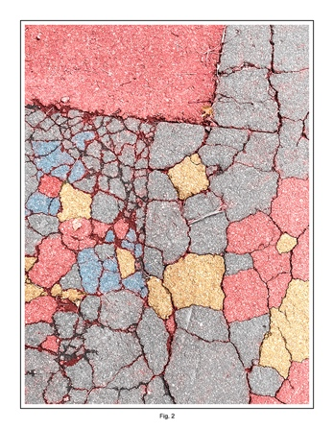

Council Papers Fig. 1 Denise Corrigan 2023
Council Papers Fig. 2 Denise Corrigan 2023

Pigment prints on cotton rag art paper, 76 x 59 cm

$350 each, Editions of 12

I took these photos of damaged municipal road surfaces in Rozelle after months of unusually heavy rain in 2022 (heavy construction vehicles also played a part in the road’s demise). I could see these shapes appearing everywhere. They reminded me of my childhood colouring-in books and the mantra ‘stay within the lines’. Colouring the images recently made me reflect more deeply on borders, ownership, progress, and climate change.

A selection of greeting cards ($6.50) is available for purchase in the gallery and online. Hand-printed @ 44 on 170 gsm matte stock, the cards come with an envelope, and are blank inside.
www.quietworks.online/shop

Thank you

Stuart Morris, Morris Fleming Design (wavy wall + glass screen)
Greg Albrecht (44 upgrade + unentitled instal) Tony Fuery (44 logo design) Belinda Daly, Darling Magazine (Balmain Rozelle Chamber of Commerce) Sue Callanan, Articulate project space Benjamin Cisterne Design (gallery lighting) Warren Macris, High Res Digital (pigment prints) Quy & Linh Nguyen, Q Printing (unentitled invitations) Luke Newbold, Newbold & Collins Bookbinders (Made in Callan Street folder)

